**PIZZA SALES SQL QUERIES**

1. **KPI’s**
2. **Total Revenue**:

SELECT SUM(total_price) AS Total_Revenue from pizza_sales

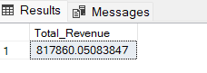

1. **Average Order Value:**

SELECT SUM(total_price) / COUNT(DISTINCT order_id) as Avg_Order_Value from pizza_sales

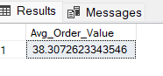

1. **Total Pizza Sold:**

SELECT SUM(quantity) AS Total_pizza_sold from pizza_sales

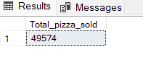

1. **Total Orders:**

SELECT COUNT(DISTINCT order_id) AS Total_Orders from pizza_sales

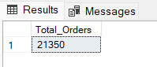

1. **Average pizzas per Order:**

SELECT CAST(SUM(quantity) AS DECIMAL(10,2)) /CAST( COUNT(DISTINCT order_id) AS DECIMAL(10,2)) AS Avg_pizza_per_order from pizza_sales

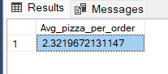

1. **Daily Trends for Total Orders:**

SELECT DATENAME(DW, order_date) as order_day, COUNT(DISTINCT order_id) AS Total_orders

from pizza_sales

GROUP BY DATENAME(DW, order_date)

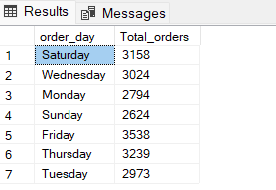

1. **Monthly Trend for Total Orders:**

SELECT DATENAME(MONTH, order_date) as Month_name, COUNT(DISTINCT order_id) as Total_orders

from pizza_sales

GROUP BY DATENAME(MONTH, order_date)

ORDER BY Total_orders DESC

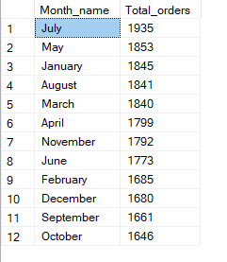

1. **Percentage of Sales by Pizza Category:**

SELECT pizza_category, sum(total_price) as Total_sales, sum(total_price)* 100 /

(SELECT sum(total_price) from pizza_sales WHERE MONTH(order_date) = 1) as PCT

from pizza_sales

WHERE MONTH(order_date) = 1

GROUP BY pizza_category

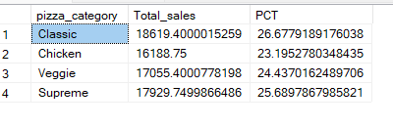

1. **Percentage of Sales by Pizza Size:**

SELECT pizza_size, sum(total_price) as Total_sales, CAST(sum(total_price)* 100 /

(SELECT sum(total_price) from pizza_sales WHERE DATEPART(quarter, order_date)=1 )as DECIMAL(10,2)) as PCT

from pizza_sales

WHERE DATEPART(quarter, order_date)=1

GROUP BY pizza_size

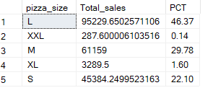

1. **Top 5 Best Seller by Pizza Sold :**

SELECT TOP 5 pizza_name, SUM(total_price) AS Total_Revenue FROM pizza_sales

GROUP BY pizza_name

ORDER BY Total_Revenue DESC

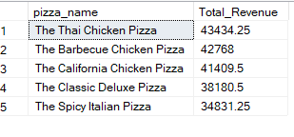

1. **Bottom 5 pizzas by Revenue**

SELECT Top 5 pizza_name, SUM(total_price) AS Total_Revenue

FROM pizza_sales

GROUP BY pizza_name

ORDER BY Total_Revenue ASC

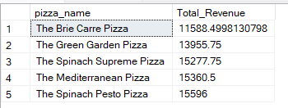

1. **Top 5 Pizzas by Quantity**

SELECT Top 5 pizza_name, SUM(quantity) AS Total_Pizza_Sold

FROM pizza_sales

GROUP BY pizza_name

ORDER BY Total_Pizza_Sold DESC

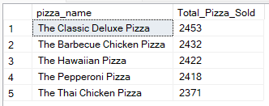

1. **Bottom 5 pizzas by Quantity**

SELECT TOP 5 pizza_name, SUM(quantity) AS Total_Pizza_Sold

FROM pizza_sales

GROUP BY pizza_name

ORDER BY Total_Pizza_Sold ASC

